Lease Agreement

1. Parties, leased property, Terms and Payment:

This agreement is made by and between:

Landlord/Lessor: Toto Sterling Tenant/ lessee: Max Smith

The Landlord herby agrees to lease the property located in:

113 Aspen Street London N4 6DT

The lease period shall be (terms of lease) starting from (13/02/2012) and shall end and may be renewable (13/02/2016) thereafter, on the agreed amount of £800 to be paid monthly, and the amount £1500 to be paid upon the execution of this agreement.

1. Use of property:

The tenant shall use the property only for residential purposes. During the term of this agreement, the tenant shall act all times with care and prudence to prevent damage to the property. The tenant must ensure the property is left in the condition as it was viewed and they are responsible for the condition of furniture as soon as they move in the property. Should the condition of the property deteriorate the tenant should ensure the landlord is aware of the condition. The landlord bears responsibility to ensure the property meets safety guidelines and meets regulations to ensure the tenants are safeguarded.

1. Utilities:

The tenant agrees to pay for the utilities and other services used in the property during the term of this agreement.

1. Furnishings:

The fixture furnishings of the property are as follows:

* Cabinets
* Kitchen table
* Dining chairs
* sofa

(list of fixture furnishings)

1. Repairs and damages:

Any loses or damages to fixture furnishings shall be paid by the tenant. If any reasonable repair is necessary for the fixture furnishing, the tenant shall ensure to notify the landlord. The landlord shall defray reasonable repair costs of fixture furnishing. The tenant is not permitted to modify or paint or materially change any constant part of the property.

1. Termination:

This agreement automatically expires at the end of the specified period above. However, this agreement shall be terminated with mutual written consent of the parties at any time.

Signed on this 5th of the February 2012

1. Modify or change lease agreement.

The tenant will have the ability to change the lease agreement should they wish to change certain things on the lease they will be able to do so after 30 days. The landlord will be able to agree or disagree with the changes of the lease.

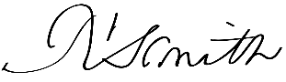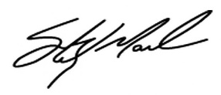Landlord (Toto Sterling) Tenant(Max Smith)

05/02/2012 05/02/2012